**Script to Update AD User Information**

The below script can be used to update a user’s AD attributes:

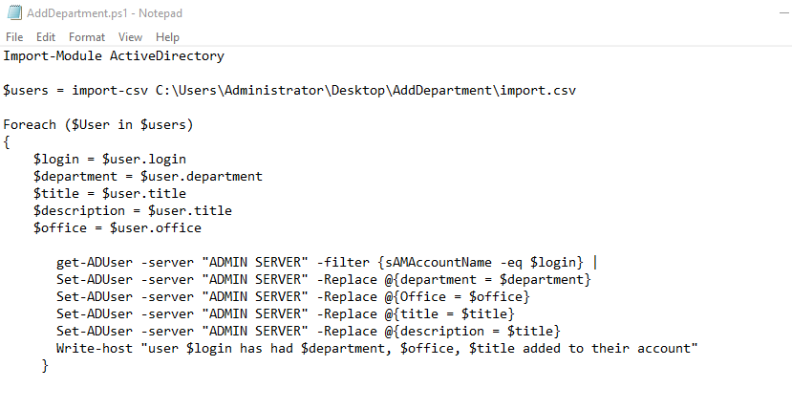

The script works by taking the four fields from the import spreadsheet and locating the user with the **Login** field and using the information in **Department and Title** to replace the respective attributes with the same name. The title field is also used to update the ad attribute “Description”

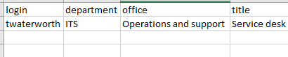

In this example the script will know to find the “Toby Waterworth” by using the login field to find the login attribute within AD, if it can’t find that attribute it will skip the user and say it has. It will then change the Department, as seen in **Fig 2** from **Information Technology Services (ITS)** to just **ITS**. It will then update the office from **ITS** to Operations and support. Finally it will change both the **Title** and **Description** of the user to **Service Desk** and display all changes in a message. Once done it will move onto the next entry within the spreadsheet, if no more entries are present the script will finish. This script can also be modified to work with almost any of the AD attribute names.

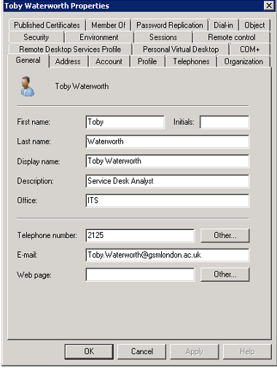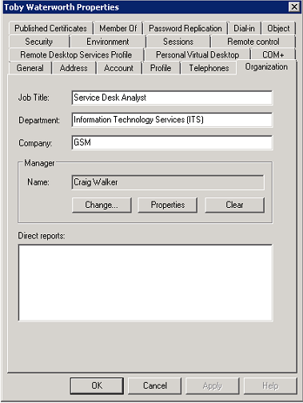

(Fig 1) (Fig 2)